ZNWK-01-829 Series Intelligent Heating Thermostat with weekly programming function, it can be set six period times & the corresponding setting temperature per day. You also can choose manual control or temporary control mode of operation. With the unique far-way control function, simple operation, energy saving and environmental protection, this thermostat can be suitable for electric heating equipment control and water system heating electric drive valve control.

1, Parameter:
Voltage：220VAC，50/60HZ | Current：Imax: 3A/16A | Accuracy：±0.5℃ | Sensor：NTC
Power consumption：<1W | Control range：5℃~45℃(35-95℃ adjustable) | Environmental temp.：-5-50℃ | IP Grade：IP20
Limitation setting：5~60℃ | Default temp. Deviation: 1℃(1-5℃ adjustable)

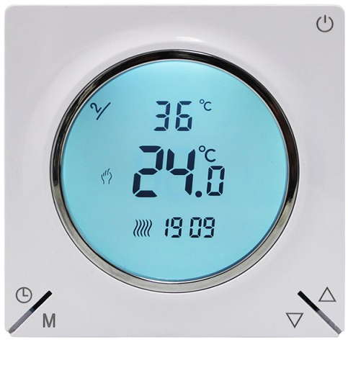
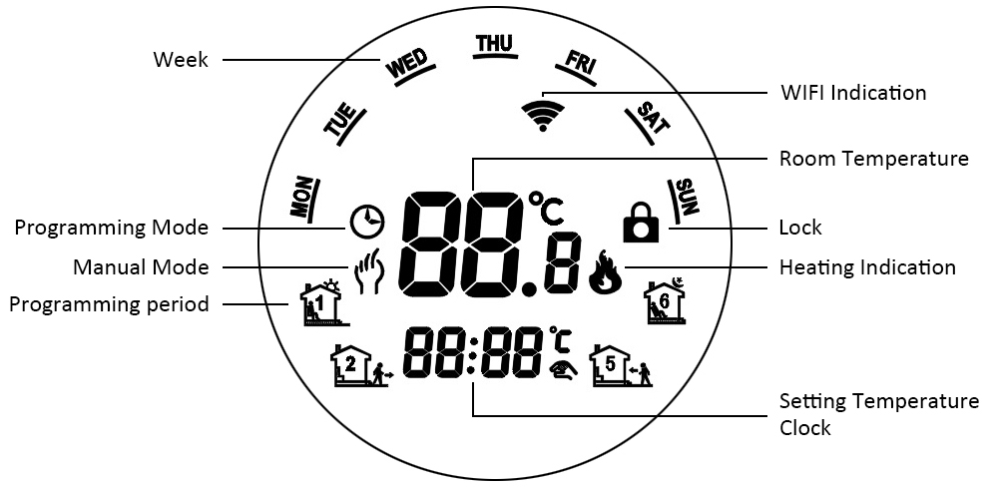
2, Panel display:
3,Function
：Manual mode: Control the device by manual.
：Programming mode: It can be controlled automatically by the set time& temperatures (with six different time & related temperature)，see below:
- , simultaneous display：For temporary control mode, press“”or“” will change to this mode, the device will comes out of the temporarily current period time control and come into the control of the manual mode, which also will automatically return to the programming mode when the next period time comes.
wake-up (a.m), event 1 | 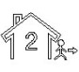Leave (a.m), event 2 | 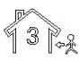Return (a.m), event 3
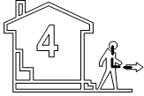Leave (p.m), event 4 | 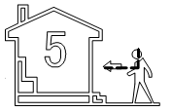Return (p.m), event 5 | Sleep (p.m), event 6
：Lock: Press the key“”&“”together for more than 5 seconds, the device locked, and press them for another 5 seconds, it will unlock again.
：Heating : Means for heating now.

4,Function of the button

：Power, ON/OFF by short press.
M：Mode, Short press for manual model& programmable mode changed.
：Clock, Short press for time setting: second setting → hour setting → week setting. Press“”for next parameter setting, the twinkled data means to be set, press“”or“”to setting and 10 seconds can be recorded after everything to be recorded.
▲：UP, for increase the related parameters or adjust working mode.
▼：DOWN, do decrease the related parameters or adjust the working mode.
Under the power on mode, press“” and “” for last 5 seconds comes into weekly programmable setting mode, press“”or“”for data change, then press “M” to come to the next setting with the related sequenceas below:
Time(Event 1) setting from Monday to Sunday →Temperature(Event 1)→…→Time(Event 6)
Press “” after finish setting each parameter for coming into the next data setting, press“” or “”to set the twinkled data, each twinkle duration keeps for 1 minute, the data can be kept in record in 10 seconds after finish setting.( see below attachment, each previous event setting time can’t over the next event time)

OPTION | Setting | Setting | From Monday to Friday
 | M  For data setting | For data setting | Period | 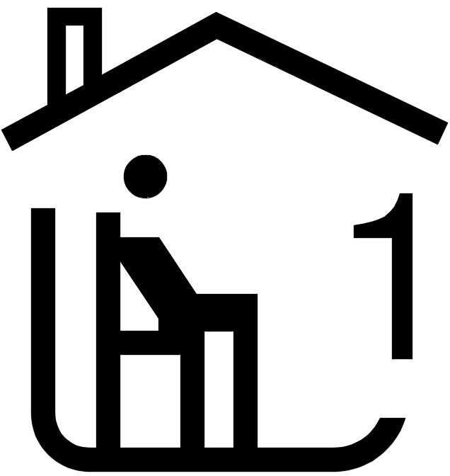 | 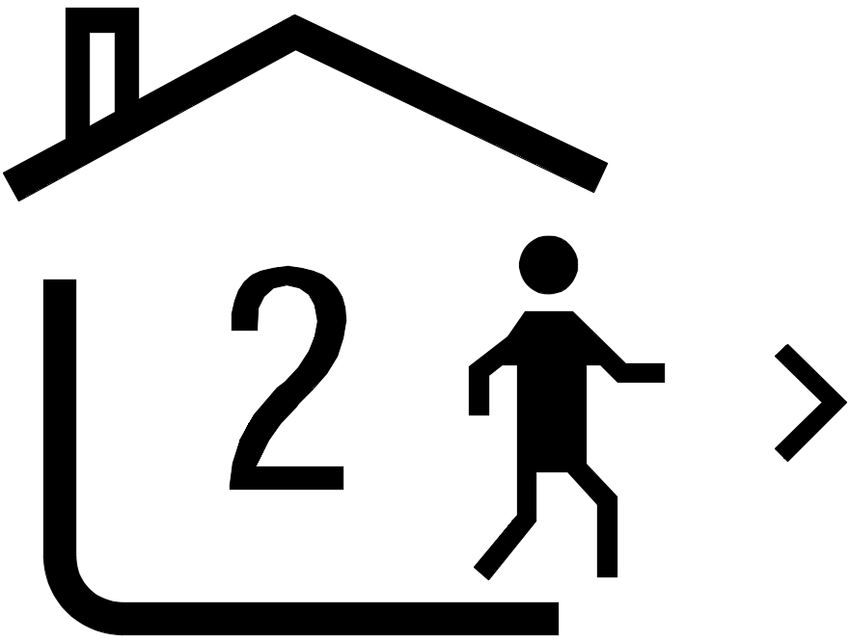 |  |  |  | 
 | M  For data setting |  | DEFAUL TIME | 6：30 | 8：00 | 11：30 | 12：30 | 18：00 | 22：30
 | M  For data setting |  | DEFAUL TEMPERATURE | 21℃ | 18℃ | 21℃ | 18℃ | 21℃ | 16℃
 | M  For data setting |  | Saturday
 | M  For data setting |  | Period
 | M  For data setting |  | DEFAUL TIME | 6：30 | 8：00 | 11：30 | 12：30 | 18：00 | 22：30
 | M  For data setting |  | DEFAUL TEMPERATURE | 21℃ | 18℃ | 21℃ | 18℃ | 21℃ | 16℃
 | M  For data setting |  | Sunday
 | M  For data setting |  | Period
 | M  For data setting |  | DEFAUL TIME | 6：30 | 8：00 | 11：30 | 12：30 | 18：00 | 22：30
 | M  For data setting |  | DEFAUL TEMPERATURE | 21℃ | 18℃ | 21℃ | 18℃ | 21℃ | 16℃

5, Advanced setting


Under the power off status, press“”&“” simultaneously for 5 seconds for coming into the advance setting mode, the screen will display all the related NO. & data, then press“”or“”for data change, then press “M” to come to the next setting, All of the parameters will be kept in record after press “”after finish setting.
Code | Option | Default parameters | Details
1Adj | Room Temperature compensation | -2 | -9℃~+9℃
2Sen | Sensor type | In | I n：internal sensor（to control and protect the temperature）  OU：external sensor（to control and protect the temperature）  AL：internal/external sensor （internal sensor is for room temperature controlling, external sensor is for temperature protection）
3Lit | Temperature limitation | 50.0 | 5~60℃
4dif | Switching Deviation | 1 | 1~5℃
5Ltp | Anti-freezing function | Off | On：start the Anti-freezing function  Off：closed the Anti-freezing function
6Hit | temperature upper limit setting | 45 | 35~95℃
7OEN | Open window detect function (OWD) | OFF | On：start the OWD function  Off：closed the OWD function
8Otl | OWD Detect Time | 15 | Range：2~30min
9Otp | OWD Drop temp. select (within detect time) | 2 | Range：2~4℃
0Pdt | OWD Delay time select (Return to previous working status) | 30 | Range：10~60min
AFAC | Factory Reset | - | when show“-”and keep press“ M” for 5 seconds until show“- - -”, it means return to the restore factory reset

6, Installing your thermostat

This product is suitable for standard 86mm wall box or european 60mm round box.

1, Connect the wire of power and other equipment into the terminals. | 2, Fix the wall plate into the wall box by a screwdriver
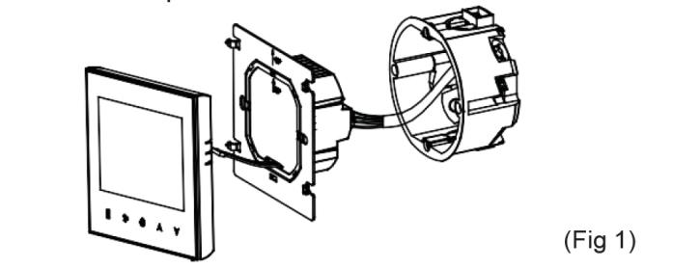 | 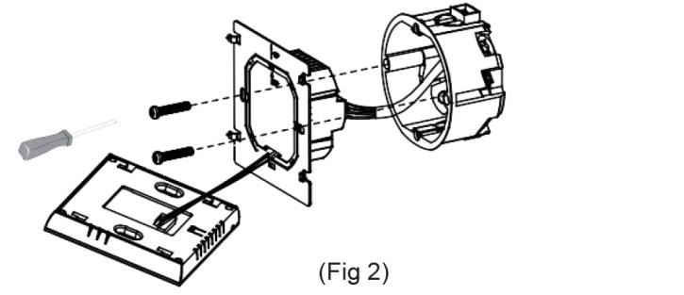
3, Connect the LCD board into the wall plate.
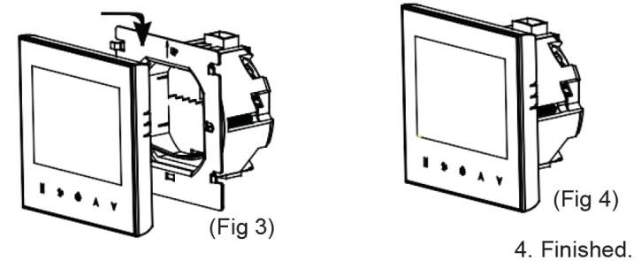 |   WARNING: Please arrange the professional technician to install this product according to installation drawing and instruction.  RISK OF ELECTRICAL SHOCK. Disconnect power supply before making electrical connection. Contact with components carrying hazardous voltage can cause electrical shock and may result in severe personal injury or death.instruction.

7, Connecting Diagram

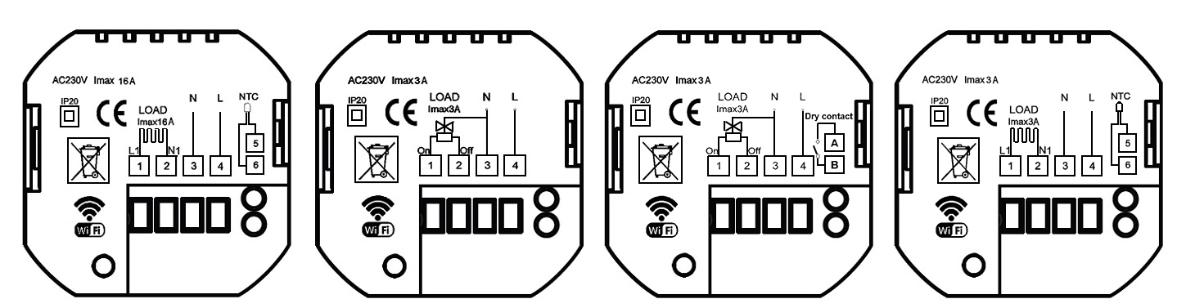
H | RH | GH | RH-NC

H (for electric floor heating)
RH (for water radiant floor heating without external sensor)
GH (for Gas boiler and water radiant floor heating without external sensor)
RH-NC (for water radiant floor heating with external sensor but only for Normally closed actuator)

8, WIFI connection & operation

***PROPOSAL: BELOW PART ARE ONLY FOR WIFI FUNCTION THERMOSTATS ONLY
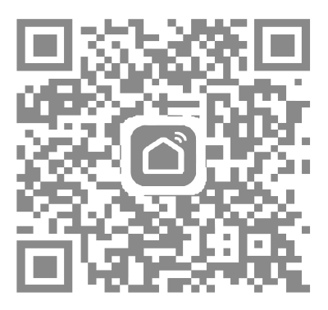 | 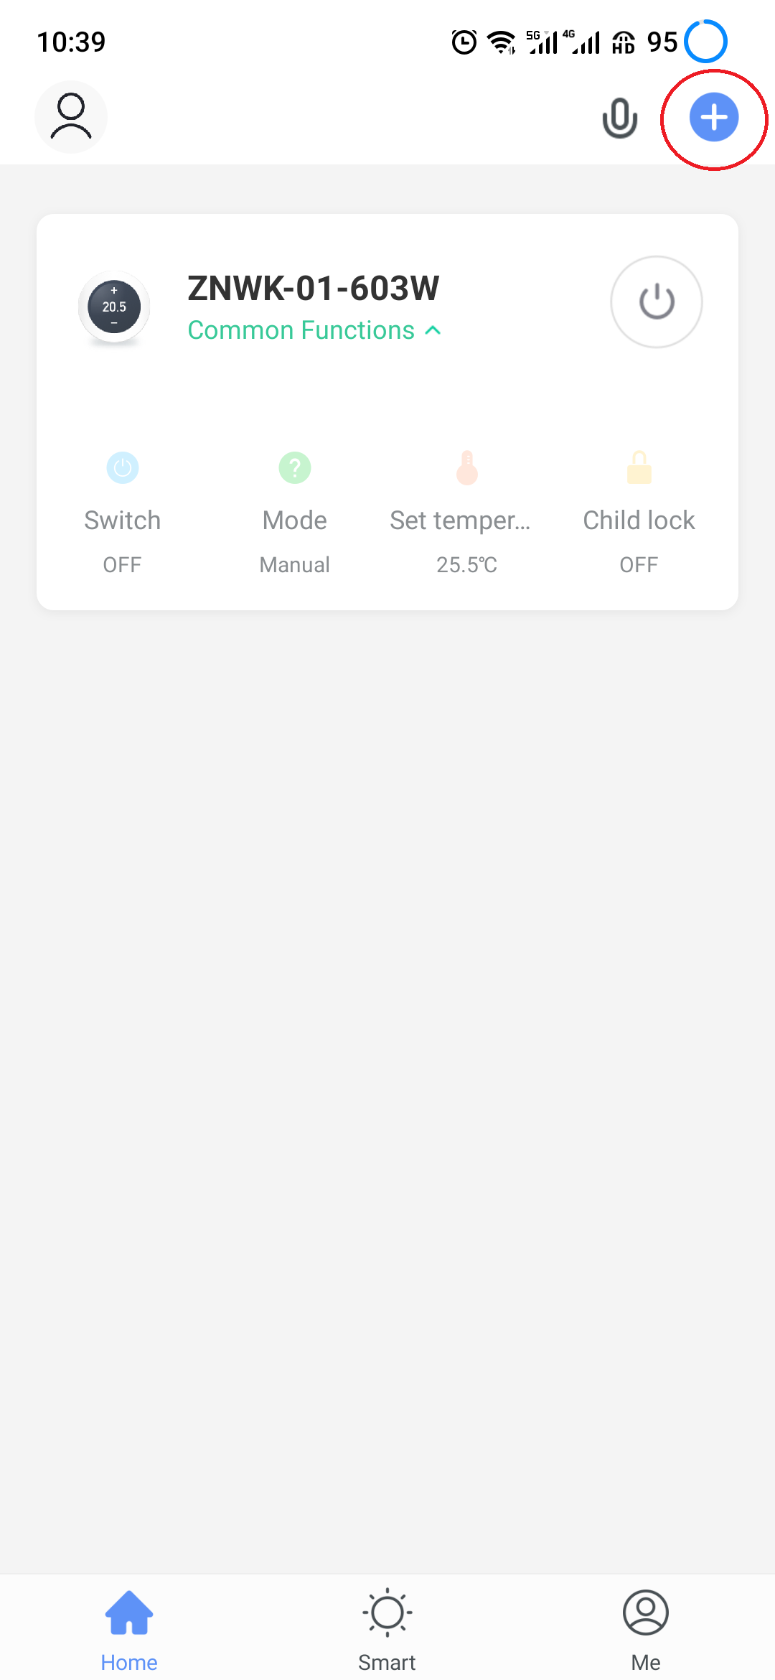 | 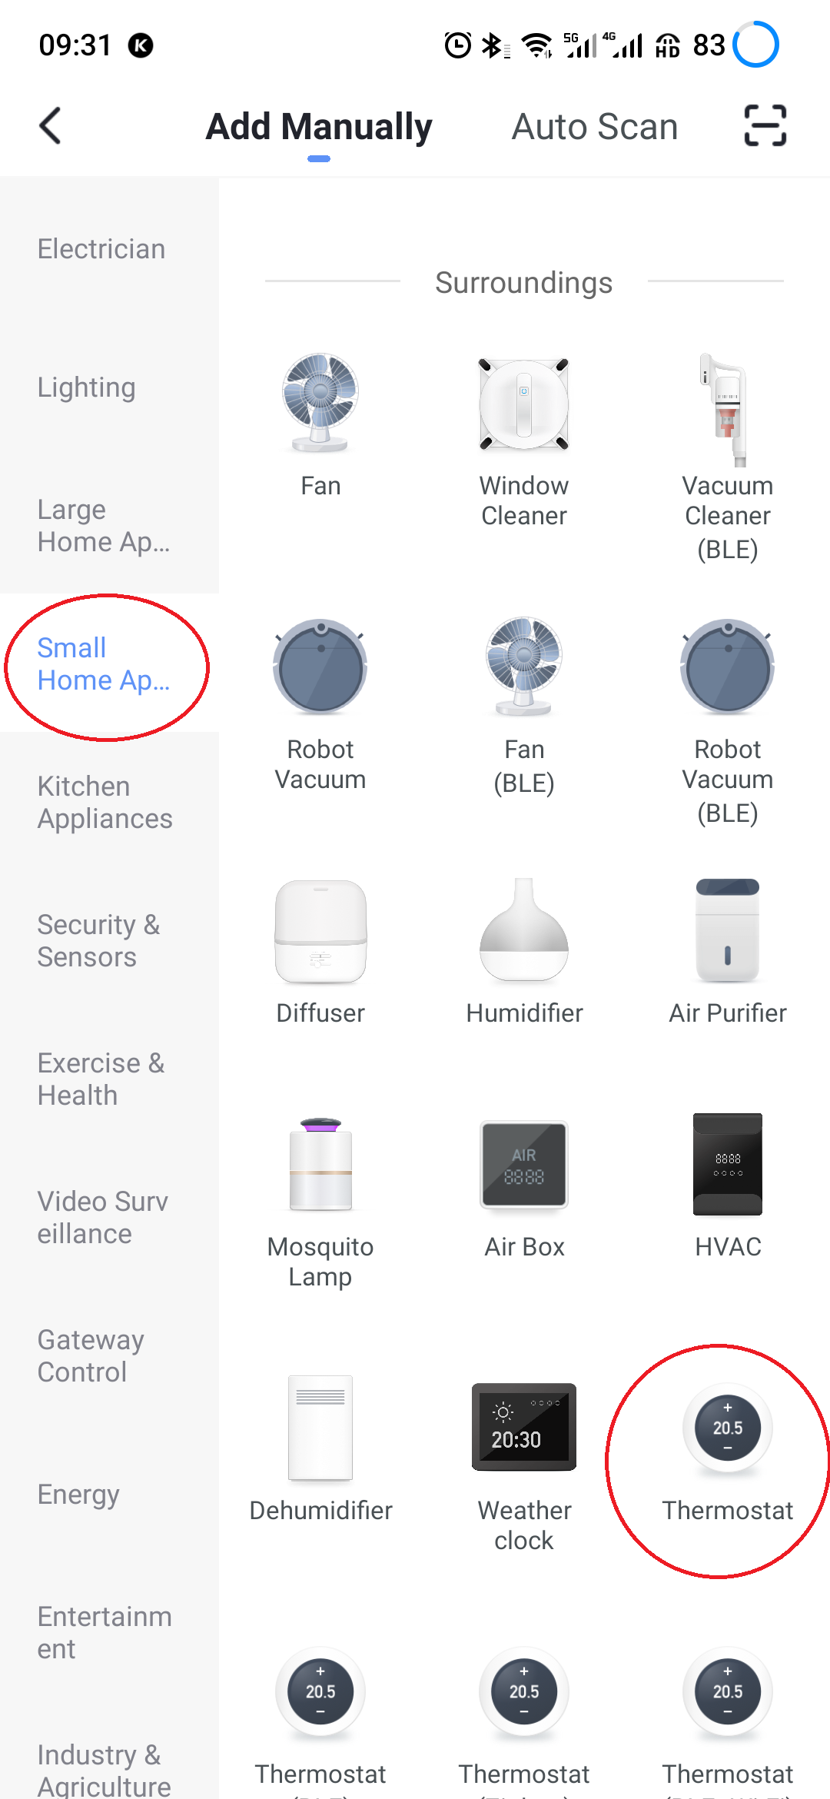
1.Scan the above QR Code by cellphone or sourcing the Apps “Smart Life” OR “Tuya Smart” at the App-store.
 | 2.After completing the account registration, click”add device” or “+” in the upper right corner of the APP main interface to add the device. | 3. Please select “Thermostat” in “Small Home Application”
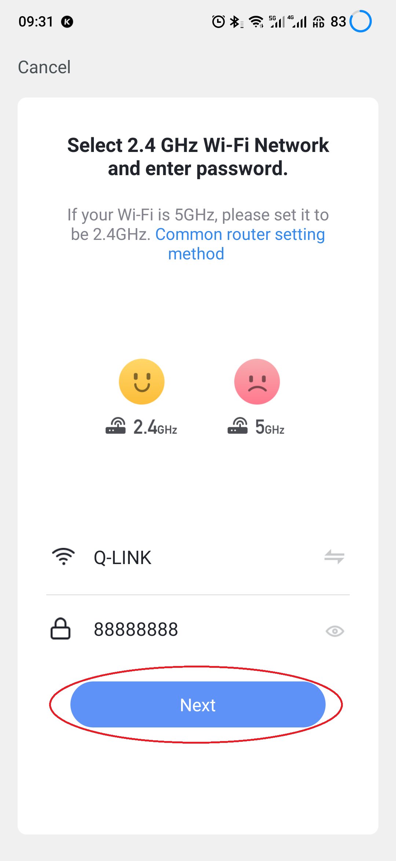 | 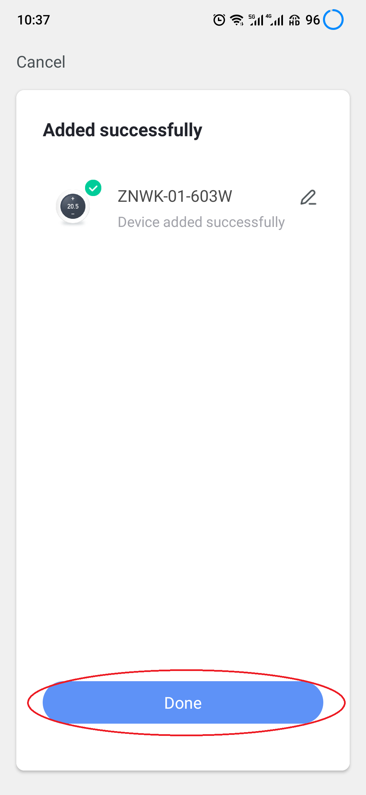 | 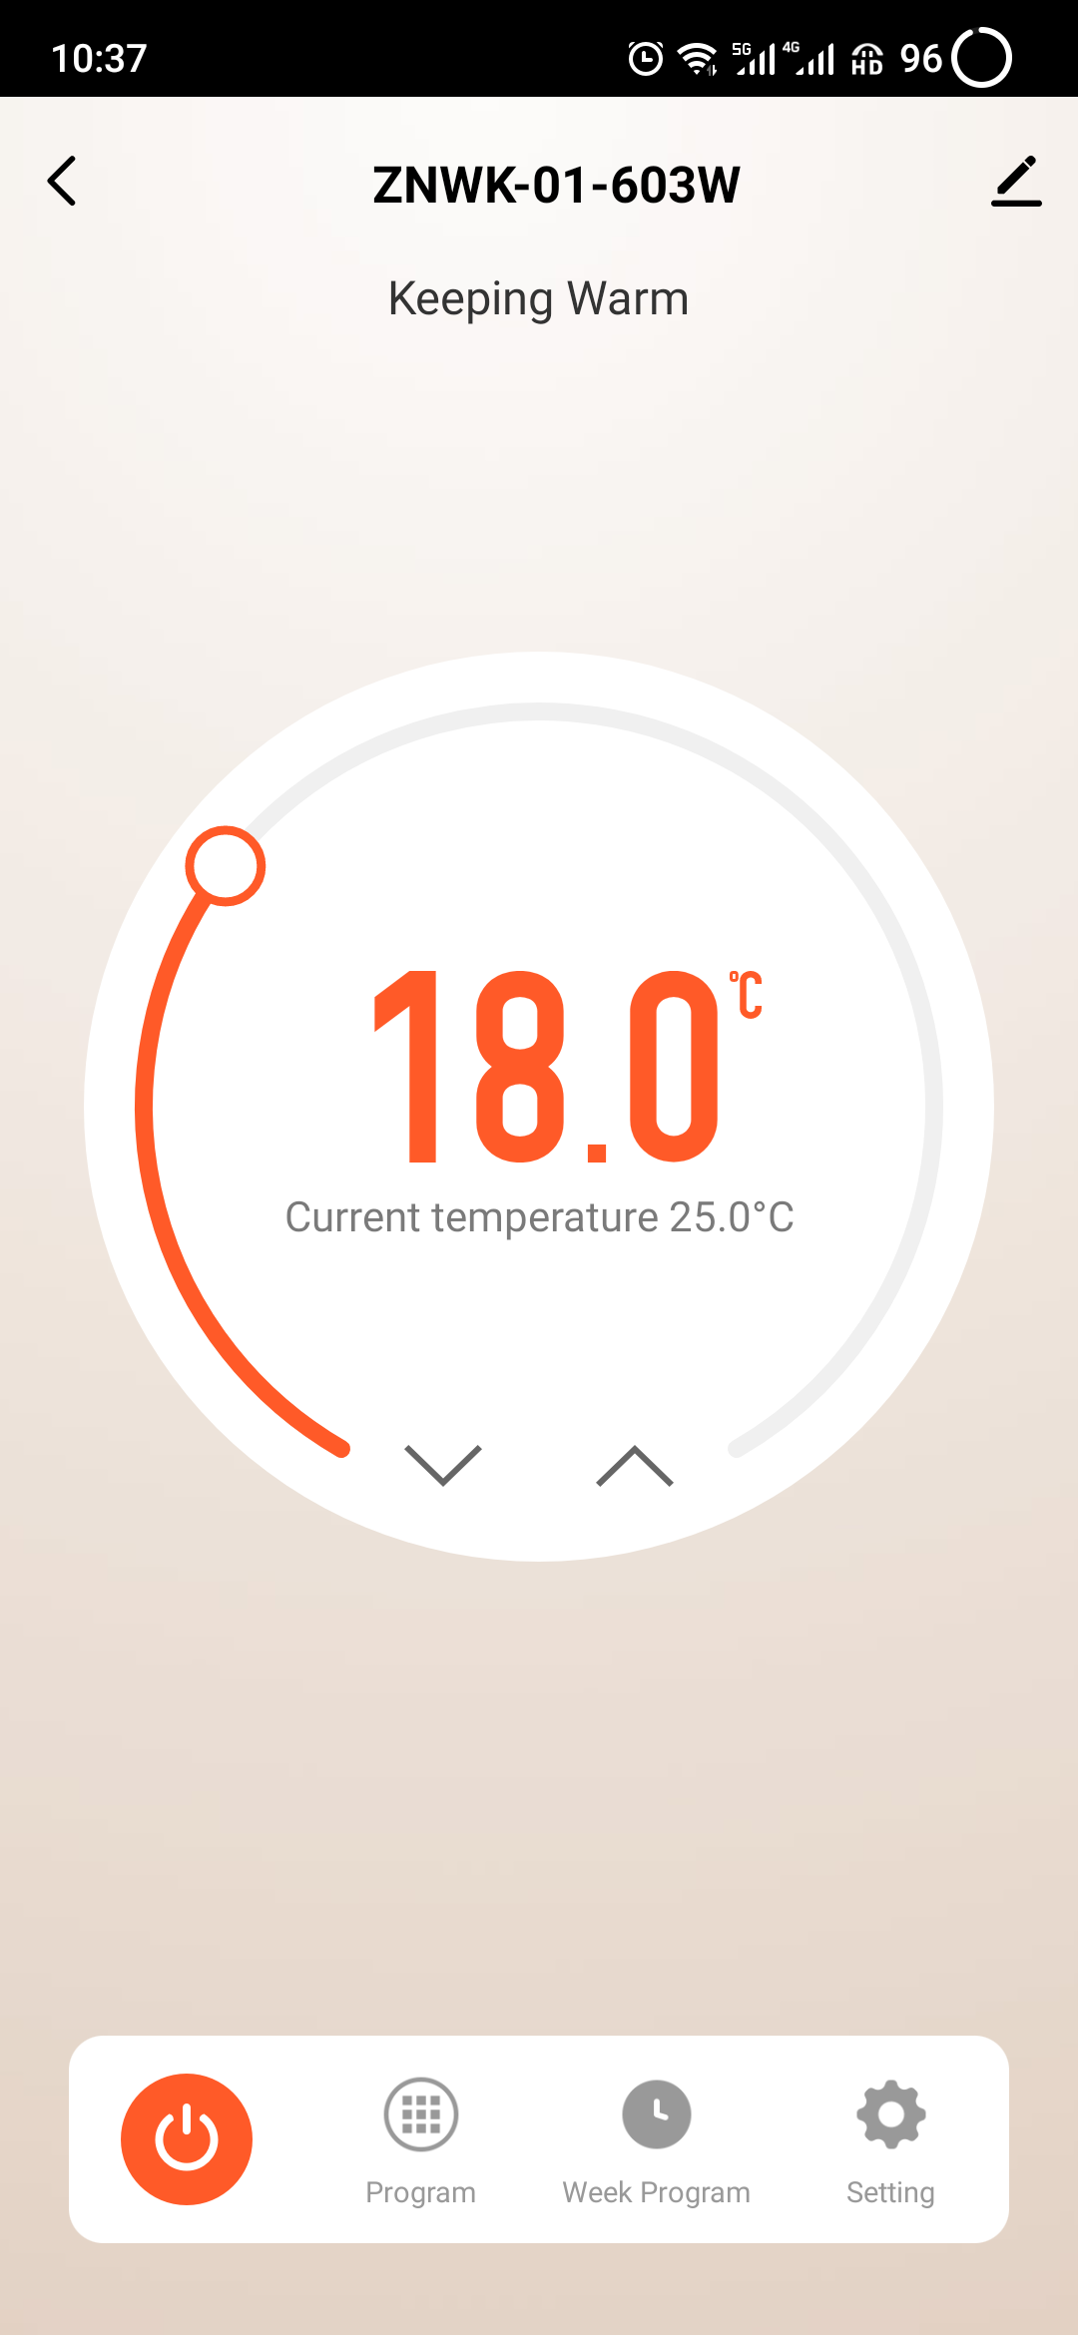
- Please long press the thermostat “” & “” key, until it show“”flashed, then click “Confirm indicator rapidly blink”, Then Enter Wi-Fi password and click “Next”, then click “Continue” to pair the devices. | 5. Waiting a few second until the device added successfully, click “Completed” to device main interface. | 6. Click on different icons to set different items for the thermostats
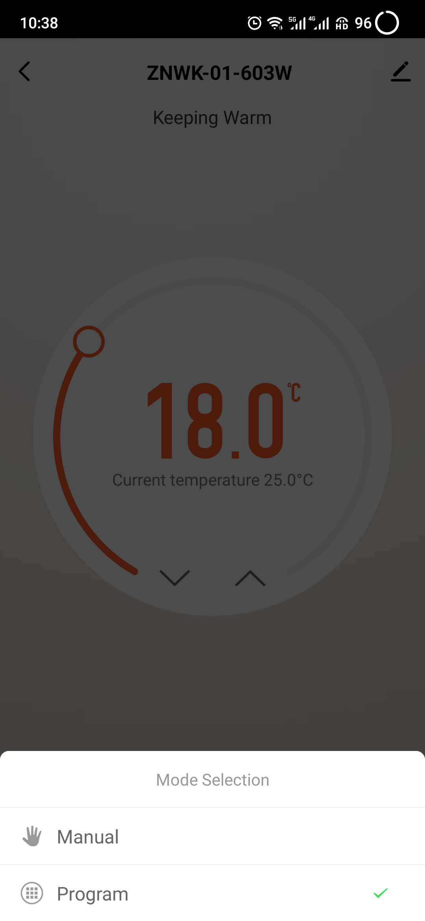 | 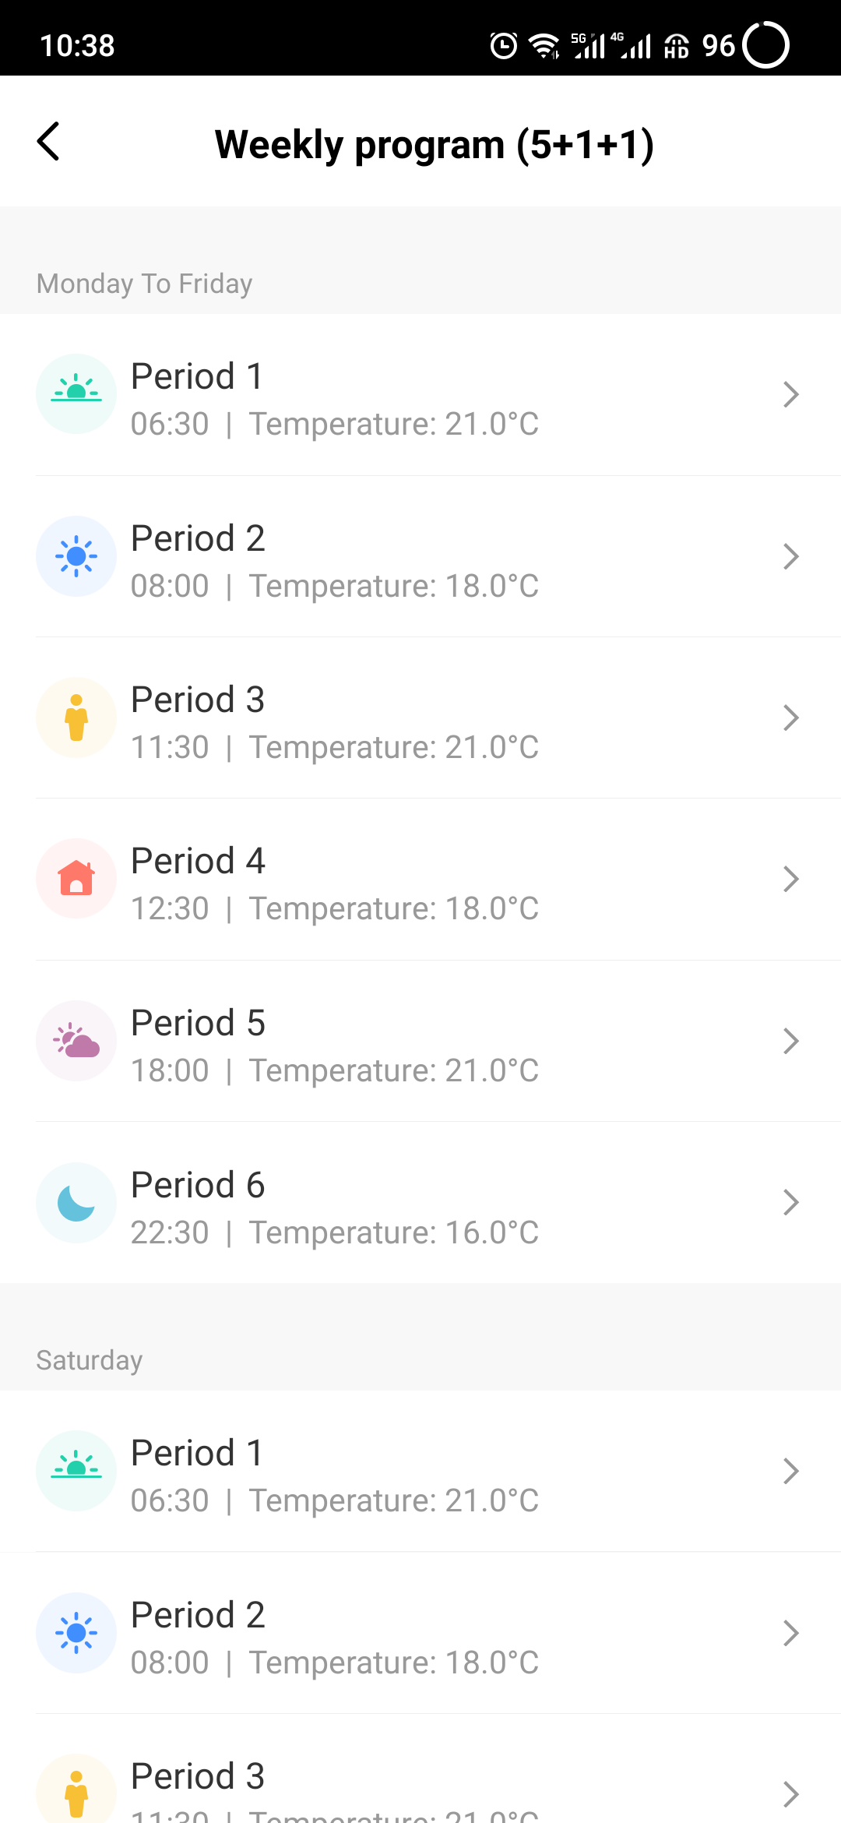 | 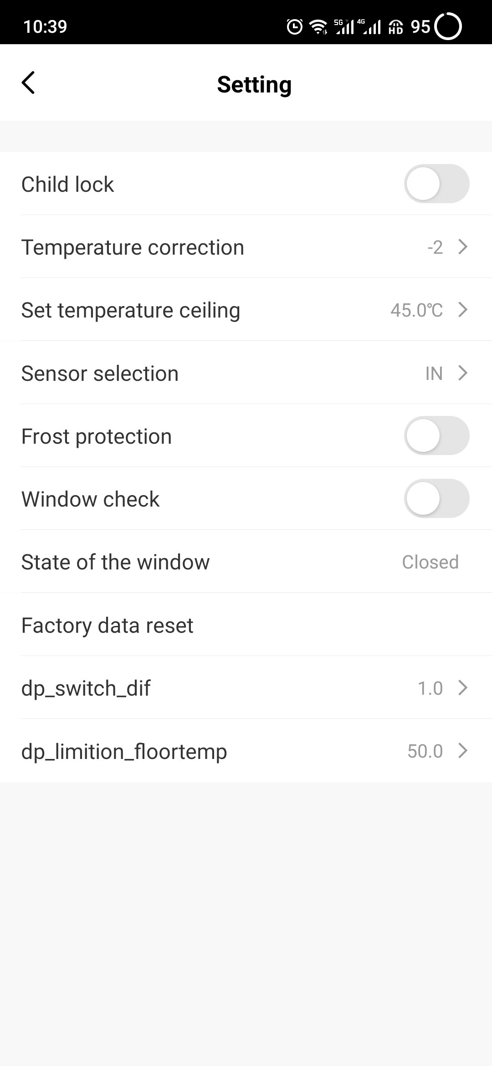
7. Set the model | 8. Set your favorite time and temperature | 9. Set the advance setting

